Planning

1. Defining the Problem

Although I grew up in a busy metropolis, my family was originally in Hainan. Instead of the video games and social media, people there enjoys to play mah-jong, a kind of table game played by 4 players with normally 144 tiles as shown below (Those in the top 4 rows have 4 pieces each, while the last row only have one each). My mother enjoys it as well. However, the problem is that people from different provinces play it with generally the same but still different rules. Typically, the mah-jong in Sichuan province only have 108 cards (They don’t have the fourth row). 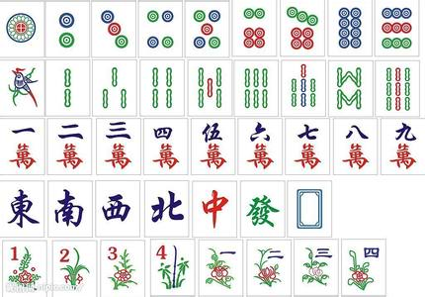The rules in Hainan allow players to draw the card discarded from the left (previous) player, which, however, is not allowed in Guangdong province. There are other numerous differences across other provinces.

Unfortunately, the mah-jong games on the internet nowadays can only satisfy some specific rules. For instance, the one produced by *Tencent Games* is specific to Sichuan rules. Therefore, my mother requires a game programmed to accommodate any set of rules once and for all. During the consultation, she also suggests that the game should be able to minimize the work needed to input of rules.

After I was told to think of what I would like to create a game or any programs, I chose this game design project which my computer science teacher, Ms. Wudi, offered and she agreed to be the advisor.

Word Count: 242

2. Rationale for choosing this project

When the electronic products begins to replace the traditional ways of playing, I think it’s time to bring the mah-jong into this trend as well. The mah-jong table is hard to set up in departments in cities, so people cannot play it there. By making the game into a computer program, people like my mother who was born in countryside and work in big cities can have their fun with mah-jong on their laptops.

Also, in the past, when people from different provinces meet together to play mah-jong, they always spend a long time reaching a common agreed rule. Even worse, if they missed some unclear rules, there would be a quarrel when the divergent rule comes into the case. If I have successfully created such a versatile program, the debate between the unclear rules could be minimized and even eliminated.

Furthermore, it will also be a good guide for those who just start to play mah-jong. Even experienced players need time to summarize all the rules and corresponding strategies. However, if I implement the rules and corresponding algorithms into the program, it will be stored and be available all the time. Therefore, when a new player use my product to get hand-on experience on mah-jong, he or she can quickly get a systematic information of how this game works.

I decided to use java for the following reasons:

* It is programmed in OOP, which is very suitable for game design.
* The program can run quickly since it’s a compiling language.
* It is good at information hiding.
* It can run on many platforms.
* It is free and does not require licensing.
* I have learnt java in my computer science class, so doing this project in python can help me review and be better at what I’ve learnt.
* It can do immediate error-detection
* The advisor has suggested

Word Count: 235 (except bullet points)

3. Success criteria

1. The shuffling, distributing, and arranging of the cards are clearly shown.
2. The user can play the game just like they do in the traditional way.
3. The program can prohibit the user to do the things the rule does not allow.
4. The program should be able to tell when a player wins.
5. The program should accommodate the player with 3 AI.
6. The AI should be powerful enough to win a normal human player occasionally.
7. The user can chose any rule possible and the AI is able to self-adjust to it.
8. The score is correctly calculated and recorded.

Appendix：

Consultation record (translated from Chinese):

Client: The mah-jong on the internet is in the Sichuan Rule, which I am not familiar with at all. Can you change that rule?1

I: Well, I can’t help you with that, but I can write a program that implements Hainan’s rule.

Client: That’s nice! But I also like to play in Guangdong’s rule sometimes.

I: Sure. How about I just let you to choose the rules before the game, so you can personalize it as will.

Client: That sounds nice, but it shouldn’t be too complicated. You know, there are sets of rules, I should also be able to do this the quick way as well.

I: OK, I’ll let the program to predict which set of rule the user is aiming for.

Client: I can offer some information about the possible rules.

I: That’s great. Any other requirements?

Client, Well… I would like the program to look as close to real life as possible.

I: You mean the Graphical User Interface?

Client: Yeah, that’s it.

I: OK, I’ll do my best.